GRADE |  | SUBJECT |  | CAT |  | WEEK |  | W2  L2 |  | TOPIC | Computer Management – Part 2
LESSON SUMMARY FOR:
DATE STARTED |  |  |  |  |  |  | DATE COMPLETED
LESSON OBJECTIVES |  |  | At the end of this lesson the learner must be able to:  - Know what Print Management is  - How to add a new peripheral like a printer  - How to change the default printer  - Understand what a print queue is  - How to delete a file that is the print queue
TEACHER ACTIVITIES |  |  |  |  |  |  |  |  | LEARNER ACTIVITIES |  |  |  | TIMING | RESOURCES NEEDED
- Methodology  NOTE TO THE TEACHER: This is a theory as well as a practical lesson on Computer Management  Use the PowerPoint presentation as an aid to this lesson  Open the PowerPoint presentation for this lesson Week 2 Lesson 4.pptx  - Introduction  This lesson will show the learner who Printer Management works,  - Add a printer  - Change the default printer  - Printing and Printing queues  - Deleting files in a queue  - Main Body (Lesson presentation)  Adding a printer  Adding new peripheral such as a printer usually connects via a USB port.  First install the cd that came with the Printer or you can go to the Control Panel, Printers and Faxes and then choose Add Printer. Using the wizard it will guide you through the installation  Changing the default of Printer  - Why do you want to change the default of a printer ?  - Let say you have a colour jet printer for photos and you have a LaserJet printer work projects and documents, you know that you are going to use the LaserJet more than the Colour Jet, and you don’t want to print a 100 page document accidentally to a colour jet print  - Start Menu  - Go to Control Panel  - Go to Printers and faxes  - Right click on the printer that you want to make the default  - On the menu that appears choose „Set as Default Printer”.  Printing Queue  When you send a document to the printer, the computer stores this file temporarily on the hard disk waiting for the printer to get ready for printing.  When you send a second document to be printed and the first document is not ready to print, these documents will be placed in a queue.  When you want to delete a document that is already been sent to the printer, you open the print queue,  Control Panel – Printers and faxes – Click on the printer  Click on the file and press the delete key, or open the Document menu and choose Delete.  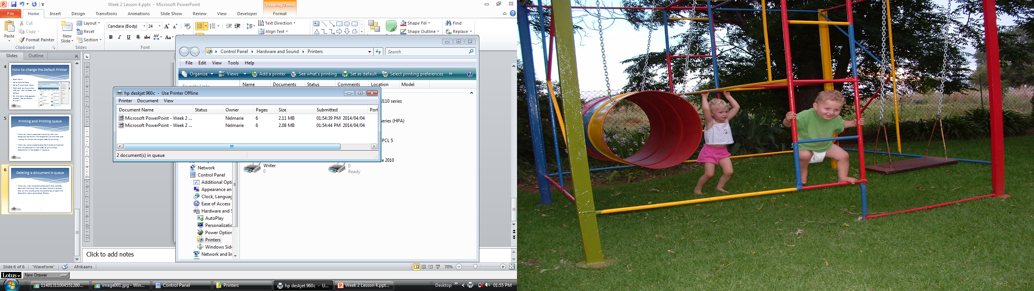  - Conclusion  Let learners know do practical lesson on how to ad, change en use the printing queue themselves, that will give them a better understanding on how the above work. |  |  |  |  |  |  |  |  |  |  |  |  | 20 min explaining the four concepts  40 min practice these concepts on the computer | Microsoft PowerPoint, Projector,  Printer,  Computer  Textbooks:  Computers part of your life Grade 10  Learners book and teachers guide  Via Africa Learners book and Teacher guide.  Focus Computer Applications technology  PowerPoint

Name of Teacher: HOD:
Sign: Sign:
Date: Date:

